The Outgussed messed from Pastebin:
Original link: https://pastebin.com/aXYZzzcv
Note: the numbers place in a table instead of being in a long column
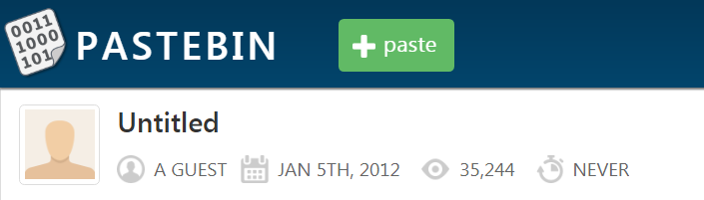
---------------------------------------------------------------------------------------------------------------------

Here is a book code. To find the book, and more information, go to http://www.reddit.com/r/a2e7j6ic78h0j/

1:20  2:3  3:5  4:20  5:5  6:53  7:1  8:8  9:2  10:4 | 11:8  12:4  13:13  14:4  15:8  16:4  17:5  18:14  19:7  20:31 | 21:12  22:36  23:2  24:3  25:5  26:65  27:5  28:1  29:2  30:18 | 31:32  32:10  33:3  34:25  35:10  36:7  37:20  38:10  39:32  40:4 | 41:40  42:11  43:9  44:13  45:6  46:3  47:5  48:43  49:17  50:13 | 51:4  52:2  53:18  54:4  55:6  56:4  57:24  58:64  59:5  60:37 | 61:60  62:12  63:6  64:8  65:5  66:18  67:45  68:10  69:2  70:17 | 71:9  72:20  73:2  74:34  75:13  76:21

Good luck.

3301

